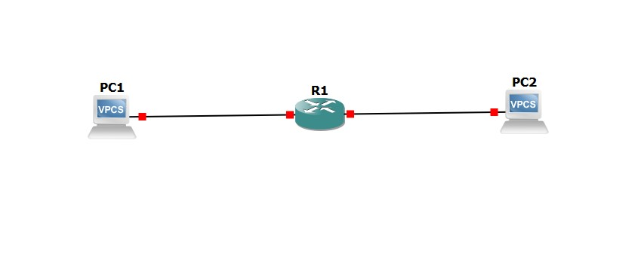  
Image 1.1 : Setting up the connection with the router to 2 VPC’s naming PC1 and PC2 .  
  
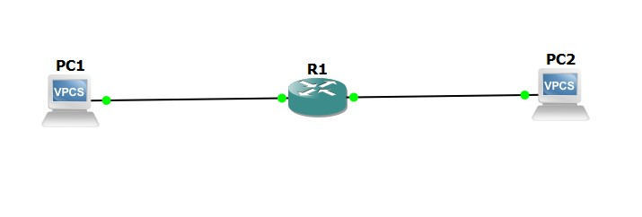  
Image 1.2 : Starting the connection between the router and the 2 VPC’s .  
  
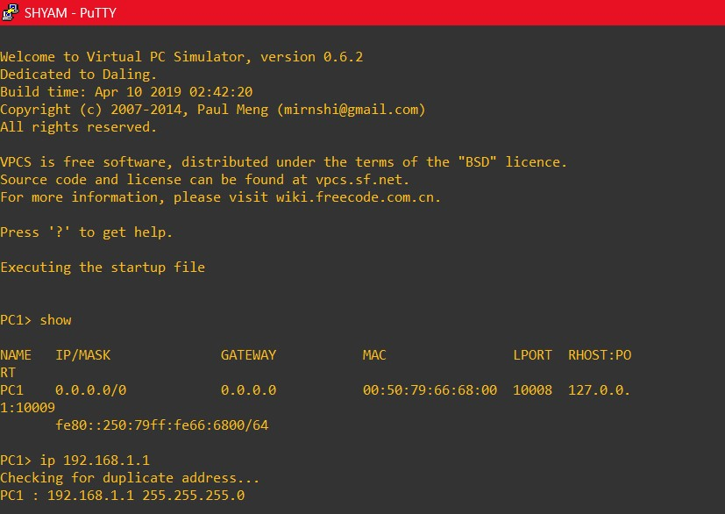  
Image 1.3 : Providing IP for PC1.   
  
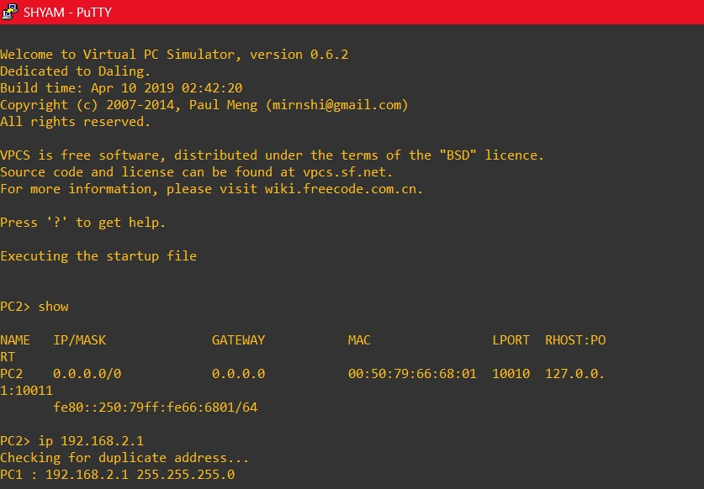

Image 1.4 : Providing IP for PC2.  
  
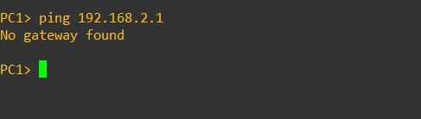   
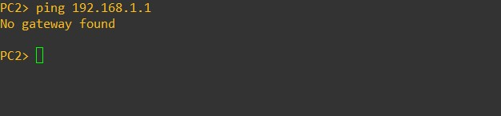  
Image 1.5 : Checking if PC2 is reachable from PC1.  
Its not reachable .  
  
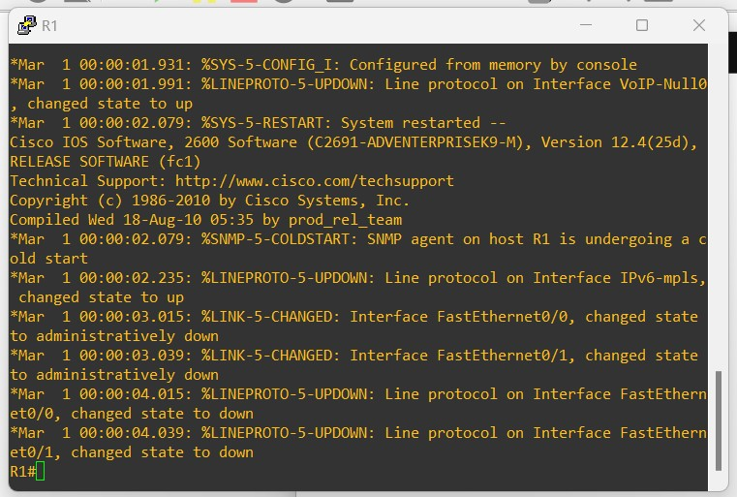  
Image 1.6 : Starting the console for router and pressing return/enter key to respond .  
  
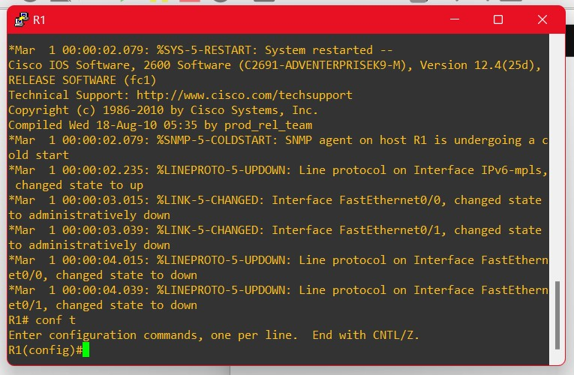  
Image 1.7 : Switching from privileged mode to config mode.  
  
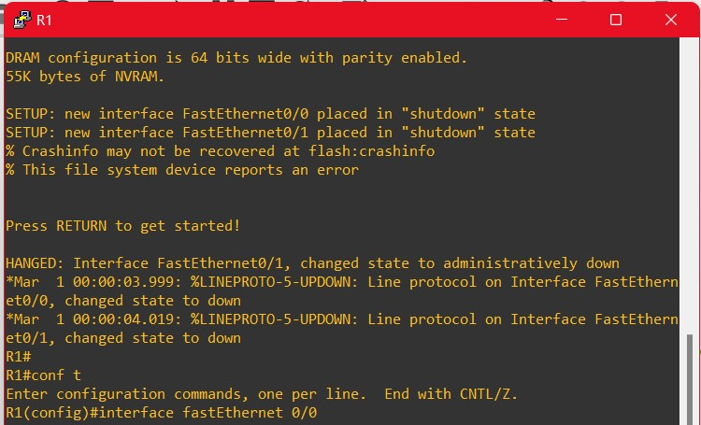  
Image 1.8 : Typing inteface fastEthernet 0/0 and taking it to a if (interface) sub-mode that allows you to configure routers first fast ethernet interface.  
  
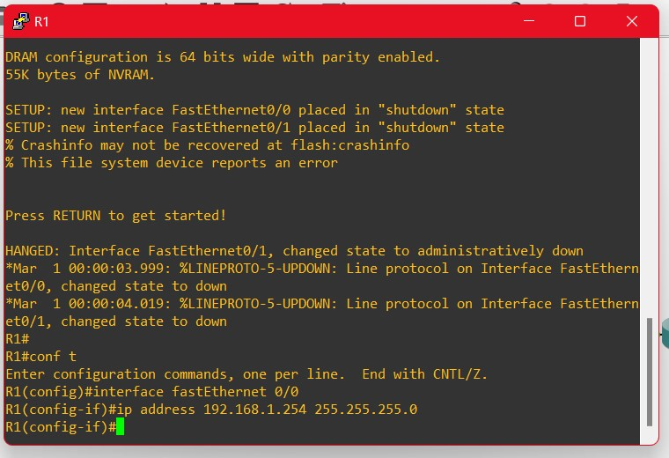  
Image 1.9 : Typing the addess to assign an IP address to the interface .  
  
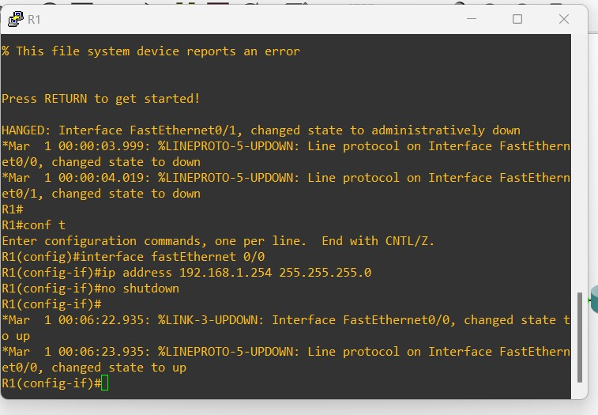  
Image 1.10 : Typing no shutdown for activating the interface .   
  
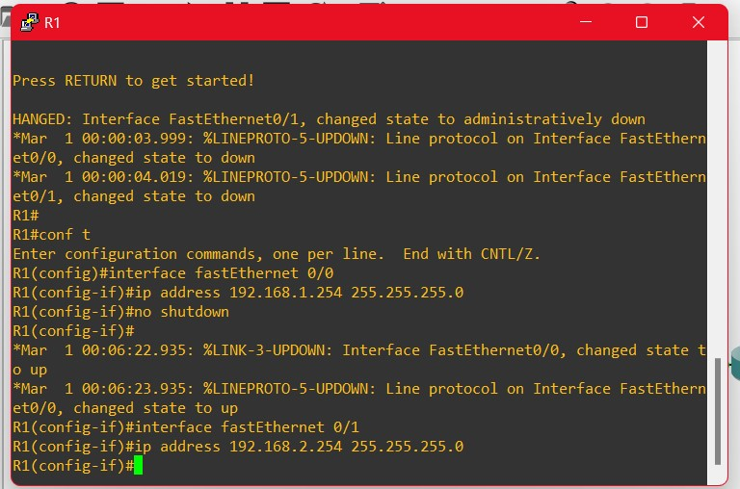  
Image 1.11 : Following the same for a interface FE0/1 using 192.168.2.254 as the IP address .  
  
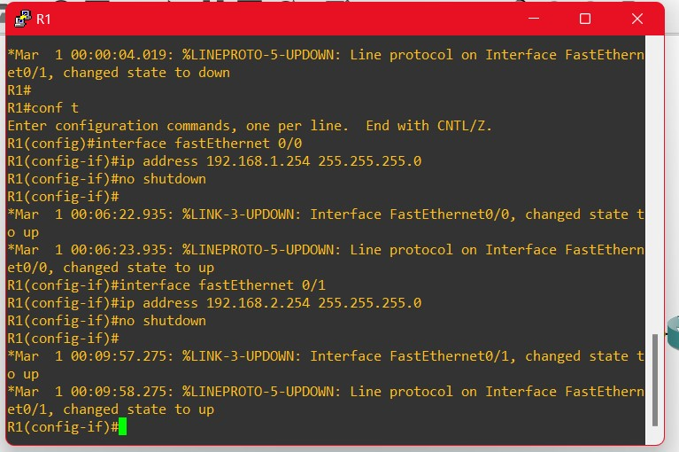  
Image 1.12 : Typing no shutdown for activating the interface .  
  
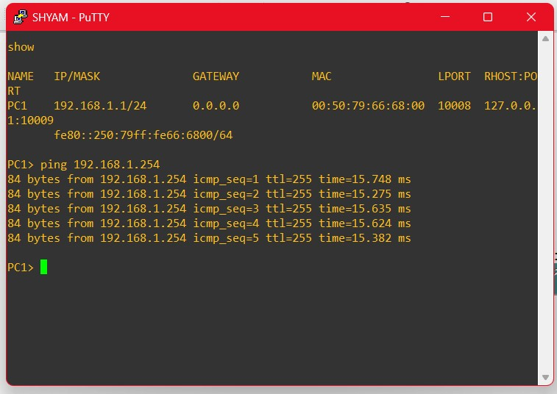  
Image 1.13 : Pinging FE0/0 from PC1.  
  
We are able to ping FE0/0 from PC1 as both interface and PC’s respectively are connected under the same network  
  
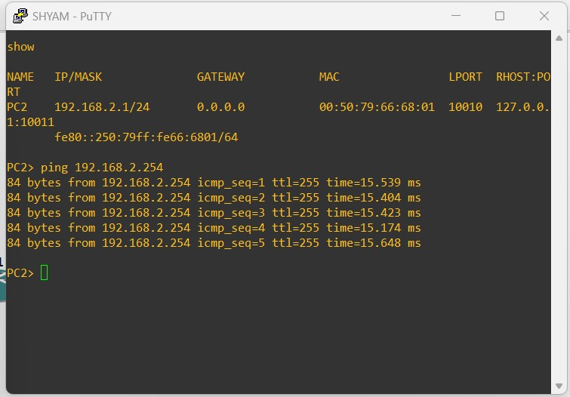  
Image 1.14 : Pinging FE0/1 from PC2.   
We are able to ping FE0/1 from PC2 as both interface and PC’s respectively are connected under the same network.  
  
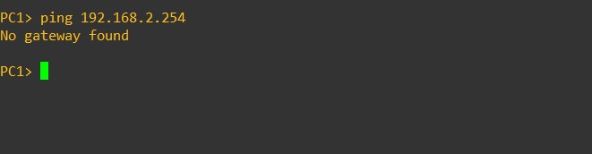  
Image 1.15 : Pinging FE0/1 from PC1.   
We are not able to ping FE0/1 from PC1 as both interface and PC’s respectively are not connected under the same network.  
  
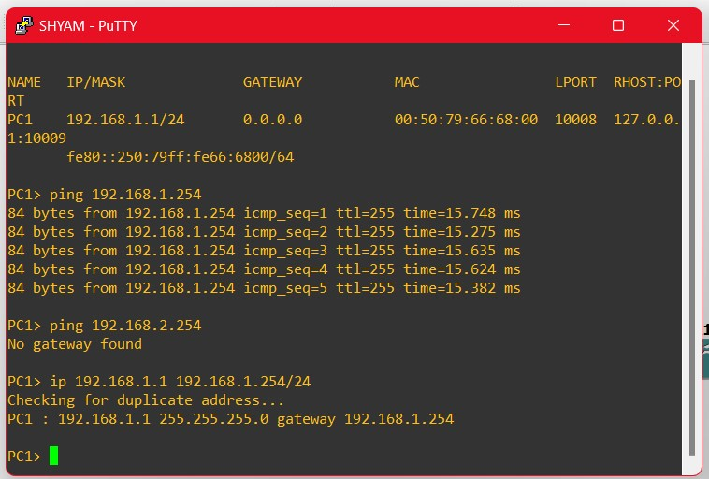  
Image 1.16 : Setting up a gateway for PC1.  
  
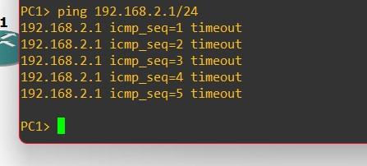  
Image 1.17 : Trying to ping PC2 from PC1.  
  
This returns as timeout as they are in different subnets. While for PC1 we have provided and IP with a gateway 192.168.1.254, PC2 has a an IP of 192.168.1.1 with no gateway.Therefore, to overcome this issue, we should provide a subnet for PC2 inorder to get pinged from PC1.  
  
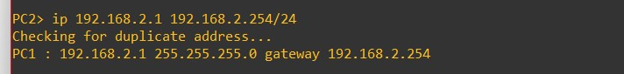  
Image 1.18 : Setting up a gateway for PC2 similar to the one we gave for PC1.

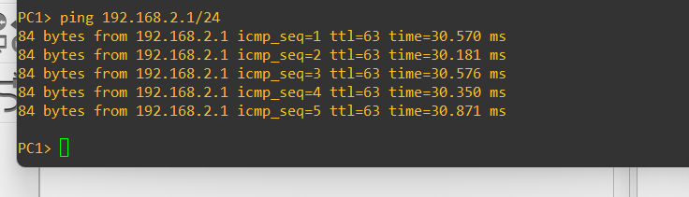  
Image1.19 : Trying to ping PC2 from PC1.